Command & Control

Analysis of Alternatives

*for the*

Unmanned

Control & Tracking System

**(UCATS)**

**DJ³K Team**

Kurt Chewning

Jennifer Greene

Dave Manley

Jeanette Smith

John Smith

Sponsors: Dr. Kuo-Chu Chang

&

Ashwin Samant



Department of Systems Engineering & Operations Research

SYST 798 Applied Project Course

Fall 2009

**TABLE OF CONTENTS**

1.0 Introduction 3

2.0 UCATS Command & Control Alternatives 3

2.1 Ground Command & Control Station (Option 1) 3

2.2 Mobile Ground Command & Control Station (Option 2) 3

2.3 In-Air Command & Control Station (Option 3) 3

2.4 Relay UAV Command & Control Station (Option 4) 3

3.0 Evaluation of Command & Control Options 3

3.2 Evaluation Methodology 3

3.3 Functional Model Evaluation 3

*3.3.1 Command & Control Option 1: Ground C2* 3

*3.3.2 Command & Control Option 2: Mobile Ground C2* 3

*3.3.3 Command & Control Option 3: In-Air C2* 3

*3.3.4 Command & Control Option 4: Relay UAV* 3

3.4 Summary 3

APPENDICES 3

APPENDIX A: Acronyms 3

# 1.0 Introduction

This document explains the analysis that was performed by Team DJ3K to determine which command and control alternative best meets the sponsor’s needs. The criteria used to determine the best option were safety, complexity, mobility, cost, required manpower, proof of concept, maintainability, communication method, and range.

# 2.0 UCATS Command & Control Alternatives

Team DJ3K considered four command and control (C2) alternatives: a ground C2 station, a mobile ground C2 station, an in-air C2 station, and a UAV C2 station. The following sections provide a description of each alternative.

## 2.1 Ground Command & Control Station (Option 1)

A stationary ground control station possesses the following advantages: high operator safety, provides distant remote UAVs command and control, and simplicity, since it can be leveraged from existing systems (which also makes this option the easiest to maintain). Some of the disadvantages are: line-of-sight communication problems and lots of manpower may be required to set up and configure. Most stationary ground control stations are over wheels and can be moved but not during use as seen in Figure 1.

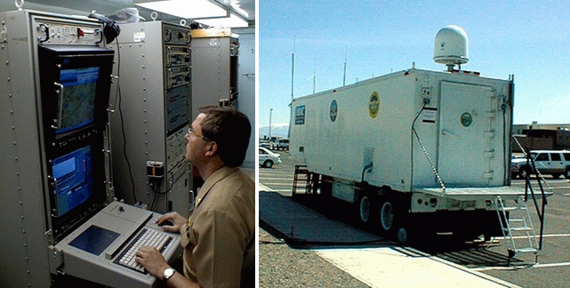

Figure 1: Ground command station

## 2.2 Mobile Ground Command & Control Station (Option 2)

A mobile ground C2 station is similar to a ground C2 station, but located inside a vehicle that may be moved during use as seen in Figure 2. It is almost as safe for the operators as option 1. The distance for the UAVs to the C2 may vary. It is a simple solution but not as simple as option 1, since there may be communication issues when in movement. This option has less line-of-sight issues than solution 1. Maintainability is comparable to option 1, but requires more maintenance due to the added mechanics of the engine. Its disadvantages are that mobility is limited by the infrastructure (roads) and traffic situation. Compact and lightweight hardware is required. This option may be more vulnerable, due to the potential lack of physical security.

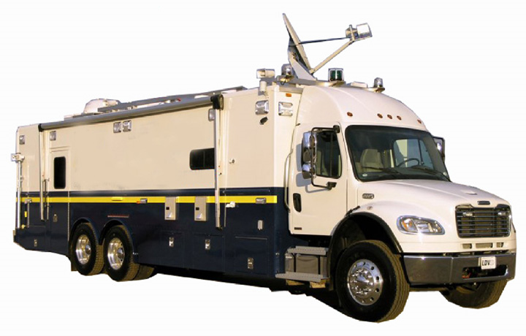

Figure 2: Mobile ground control station

## In-Air Command & Control Station (Option 3)

An in-air C2 station would consist of deploying an AWACS-style (Airborne Warning and Control System) unit that would Command and Control from above or from a safe distance. AWACS techniques have been around since the 1940’s so it is a proven technique. It is relatively safe but not as safe as being on the ground. There is a low incidence of line-of-sight communication issues. This option also has a greater communication range than the first two options. An in-air C2 station would have good mobility and deployment time. However, this option requires more manpower to operate and maintain and will have a significantly high cost associated with operation and maintainability. This option is more complex than the first two alternatives since it requires more operators. A possible vulnerability exists, due to a lack of physical security. An example of an in-air command station is seen in Figure 3.

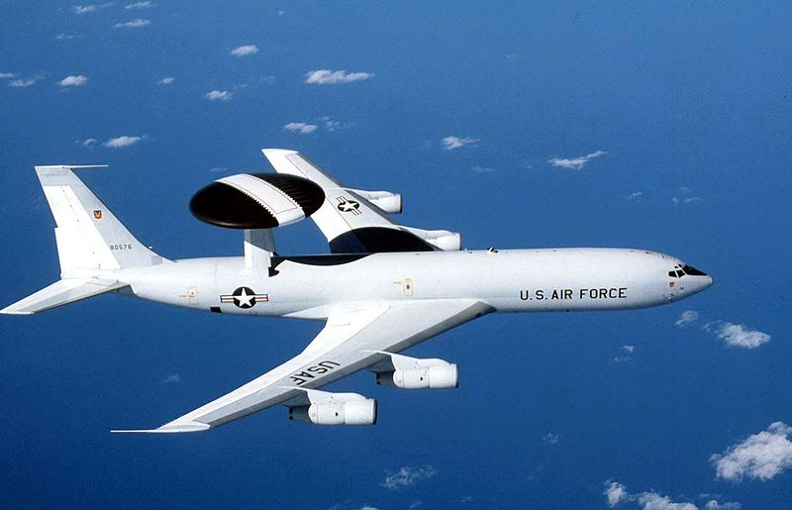

Figure 3: The E-3 Sentry is an example of an AWACS aircraft that provides all-weather surveillance, command, control and communications needed by commanders of U.S. and NATO air defense forces.

## 2.4 Relay UAV Command & Control Station (Option 4)

This alternative consists of a relay UAV and a ground C2 Station infrastructure. This means that an extra non-tracking UAV will be deployed, which will hover above or near the other tracking UAVs. It will relay all communications to a ground C2 station similar to the first solution. This solution is less safe than solution 1 since it will have an additional UAV (each additional UAV increases the risk of collateral damage due to crashes or accidents), but the ground C2 will be distant. The line-of-sight issues are little to none, assuming that this UAV can move to obtain the optimal relay position. It is less costly and manpower-intense than solution 3. This solution is more complex and costly than solution 1. This technique is not common, which may negatively impact maintainability.

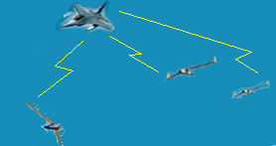

Figure 4: A relay UAV relay flies above others UAVs

# 3.0 Evaluation of Command & Control Options

## 3.2 Evaluation Methodology

Team DJ3K evaluated the proposed UCATS C2 options by conducting a multi-attribute trade study using a utility model to evaluate the proposed concepts. Table 1 summarizes the evaluation criteria and their respective weighting of the utility model.

|  |  |  |  |
| --- | --- | --- | --- |
| **Criteria** | | **Weighting** | |
| **Description** | **Justification for Criteria** | **Value** | **Reason for Weighing** |
| Safety | The safety of the operator and the surrounding civilians is one of the main concerns of this project. | 0.13 | This criterion is the third most important criterion and as equally important as Required Manpower. |
| Complexity | It is desired to keep the solution as simple as possible. | 0.10 | This criterion is half as important as the Communication Method, and as equally important as Proof of Concept and Cost. |
| Mobility | The ability to move the C2 helps improve the flexibility of the system. | 0.02 | This is the least most important criterion. |
| Cost | It is desired to keep costs as low as possible. | 0.10 | This criterion is half as important as the Communication Method, and as equally important as Complexity and Proof of Concept. |
| Required Manpower | The goal is to reduce manpower. | 0.13 | This criterion is the third most important criterion and as equally important as Safety. |
| Proof of Concept | Proven technology is more desirable. | 0.10 | This criterion is half as important as the Communication Method, and as equally important as Complexity and Cost. |
| Maintainability | An easier to maintain C2 improves availability and reduces maintenance costs. | 0.05 | This criterion is half as important as Complexity and Proof of Concept |
| Communication Method | The reliability of the communications determines the success of a mission. | 0.20 | This is the most important criterion. |
| Range | Long range of deployments are desirable. | 0.17 | This is the second most important criterion. |

Table 1: UCATS C2 Evaluation Criteria and Weighting

Team DJ3K also decided to break the cost criterion down into two sub-criteria: life cycle cost and development cost. Table 2 illustrates the cost weights.

|  |  |  |  |
| --- | --- | --- | --- |
| **Criteria** | | **Weighting** | |
| **Cost Type** | **Justification for Criteria** | **Value** | **Reason for Weighing** |
| **Life Cycle** | Life cycle costs include operations, maintenance, replacement, and disposal. | 0.5 | Both costs have equal importance at this time. |
| **Development** | Development costs include design, integration, testing, production, and planning. | 0.5 | Both costs have equal importance at this time. |

Table 2: Cost Sub-criteria and Weighting

Team DJ3K then evaluated each concept against each criterion by assigning a score of 0 to 10. A score of 0 meant the concept did not satisfy that criterion. A score of 10 meant that concept best met that criterion. Team DJ3K then multiplied the criterion score by the weighting and summed all the products to obtain a final score for the concept. The highest score was considered the best concept.

Table 3 shows the scores assigned to each option for all criteria.

|  |  |  |  |  |
| --- | --- | --- | --- | --- |
|  | Options | | | |
| **Criteria** | **1** | **2** | **3** | **4** |
| **Safety** | 10 | 6 | 3 | 8 |
| **Complexity** | 10 | 8 | 5 | 3 |
| **Mobility** | 1 | 10 | 10 | 1 |
| **Cost** | 10 | 7.5 | 2.5 | 3.5 |
| **Required Manpower** | 10 | 8 | 1 | 9 |
| **Proof of Concept** | 10 | 9 | 8 | 4 |
| **Maintainability** | 10 | 8 | 1 | 9 |
| **Communication Method** | 5 | 5 | 8 | 7 |
| **Range** | 6 | 7 | 8 | 10 |

Table 3: UCATS C2 Evaluation Details

The cost scores were evaluated using the sub-criteria scores. The latter were multiplied by their corresponding weights and summed to obtain the cost scores. Figure 4 shows the sub-criteria scores.

|  |  |  |  |  |
| --- | --- | --- | --- | --- |
|  | Options | | | |
| **Cost Type** | **1** | **2** | **3** | **4** |
| **Life Cycle** | 10 | 7 | 1 | 5 |
| **Development** | 10 | 8 | 4 | 2 |

Table 4: Cost sub-criteria scores.

## 3.3 Functional Model Evaluation

Table 3 summarizes Team DJ3K evaluation of the proposed C2 options. In summary, Team DJ3K concluded that a ground C2 station best met the criteria.

|  |  |  |  |  |  |  |  |  |  |
| --- | --- | --- | --- | --- | --- | --- | --- | --- | --- |
| **Criteria** |  | **1** | | **2** | | **3** | | **4** | |
|  | **Eval** | **Score** | **Eval** | **Score** | **Eval** | **Score** | **Eval** | **Score** |
| **Safety** | Weight | 0.13 | | | | | | | |
| Score | 10 | 1.3 | 6 | 0.78 | 3 | 0.39 | 8 | 1.04 |
| **Complexity** | Weight | 0.10 | | | | | | | |
| Score | 10 | 1 | 8 | 0.8 | 5 | 0.5 | 3 | 0.3 |
| **Mobility** | Weight | 0.02 | | | | | | | |
| Score | 1 | 0.02 | 10 | 0.2 | 10 | 0.2 | 1 | 0.02 |
| **Cost** | Weight | 0.10 | | | | | | | |
| Score | 10 | 1 | 7.5 | 0.75 | 2.5 | 0.25 | 3.5 | 0.35 |
| **Required Manpower** | Weight | 0.13 | | | | | | | |
| Score | 10 | 1.3 | 8 | 1.04 | 1 | 0.13 | 9 | 1.17 |
| **Proof of Concept** | Weight | 0.10 | | | | | | | |
| Score | 10 | 1 | 9 | 0.9 | 8 | 0.8 | 4 | 0.4 |
| **Maintainability** | Weight | 0.05 | | | | | | | |
| Score | 10 | 0.5 | 8 | 0.4 | 1 | 0.05 | 1 | 0.05 |
| **Communication Method** | Weight | 0.20 | | | | | | | |
| Score | 5 | 1 | 5 | 1 | 8 | 1.6 | 7 | 1.4 |
| **Range** | Weight | 0.17 | | | | | | | |
| Score | 6 | 1.02 | 7 | 1.19 | 8 | 1.36 | 10 | 1.7 |
| **Total** | | 7.64 | | 6.66 | | 5.23 | | 6.38 | |

Table 4: UCATS C2 Evaluation Summary

### *3.3.1 Command & Control Option 1: Ground C2*

This option scored a total of 7.64 and had the highest rating, therefore this was the best option.

### *3.3.2 Command & Control Option 2: Mobile Ground C2*

This option scored a total of 6.66, and had the second highest rating.

### *3.3.3 Command & Control Option 3: In-Air C2*

This option scored a total of 5.23, and had the worst rating.

### *3.3.4 Command & Control Option 4: Relay UAV*

This option had the third highest score with 6.38.

## 3.4 Summary

An analysis of alternatives was performed on four possible solutions for a C2 station and DJ3K determined that the best option was a ground C2 station. The four options were scored on eight criteria, which were weighted based on the team’s objectives. These values were used to determine the final score for each option. This analysis will be reviewed by the sponsor for approval.

# APPENDICES

# APPENDIX A: Acronyms

AWACS Airborne Warning and Control System  
C2 Command and Control

TOI Target of Interest

UAV Unmanned Aerial Vehicle

UCATS Unmanned Control & Tracking System